|  |  |  |  |  |  |
| --- | --- | --- | --- | --- | --- |
| Date | 6-Dec-22 | | | Tester Name | Mohammad Yusuf |
| Environment | Penfax - Test | | | Login used |  |
| Operating System | Windows | Version: | Update: | | |
| Software Used | Select Software | Version: | Update: | | |
| Select Software | Version: | Update: | | |
| Release version |  | | | | |
| Title |  | | | | |
| Test Type | Regression | | | | |
| Test Scenario |  | | | | |
|  |  | | | | |
| Expected Results |  | | | | |
| Pass/Fail | Select | | | JIRA# | N/A |

Describe your steps with screenshots:

Find an Active MEPP Member. Eligible to Retire

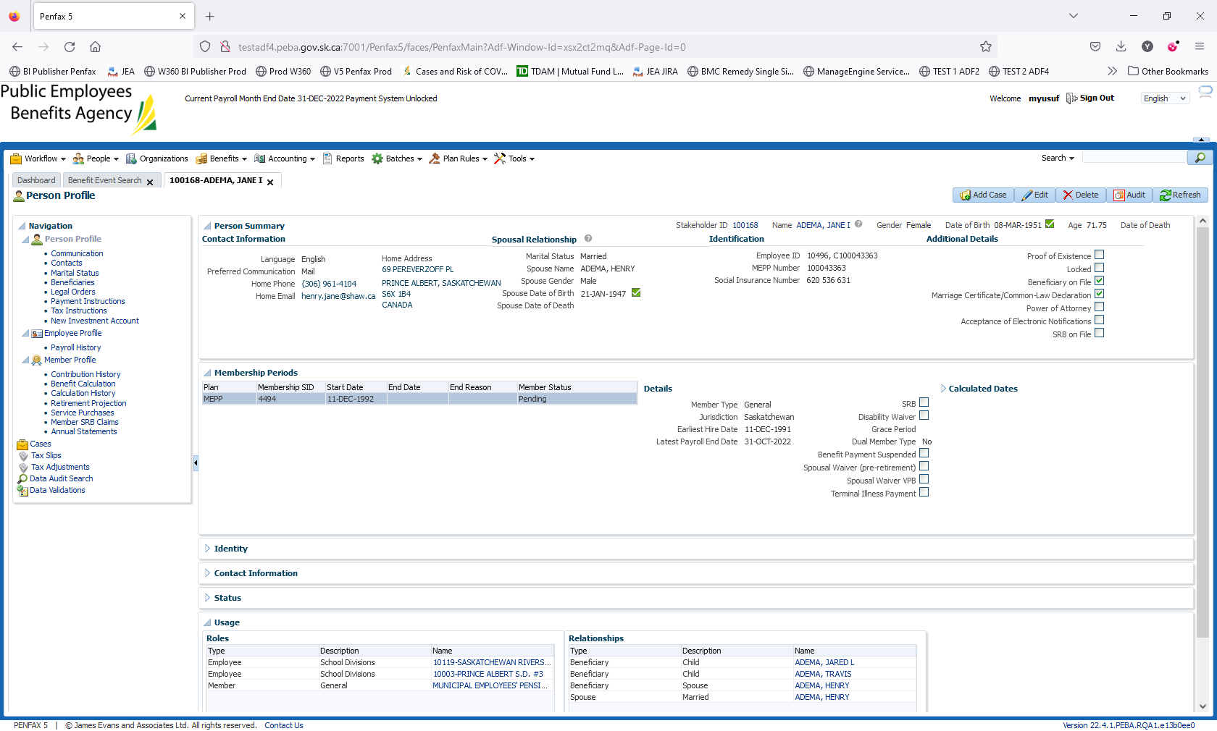

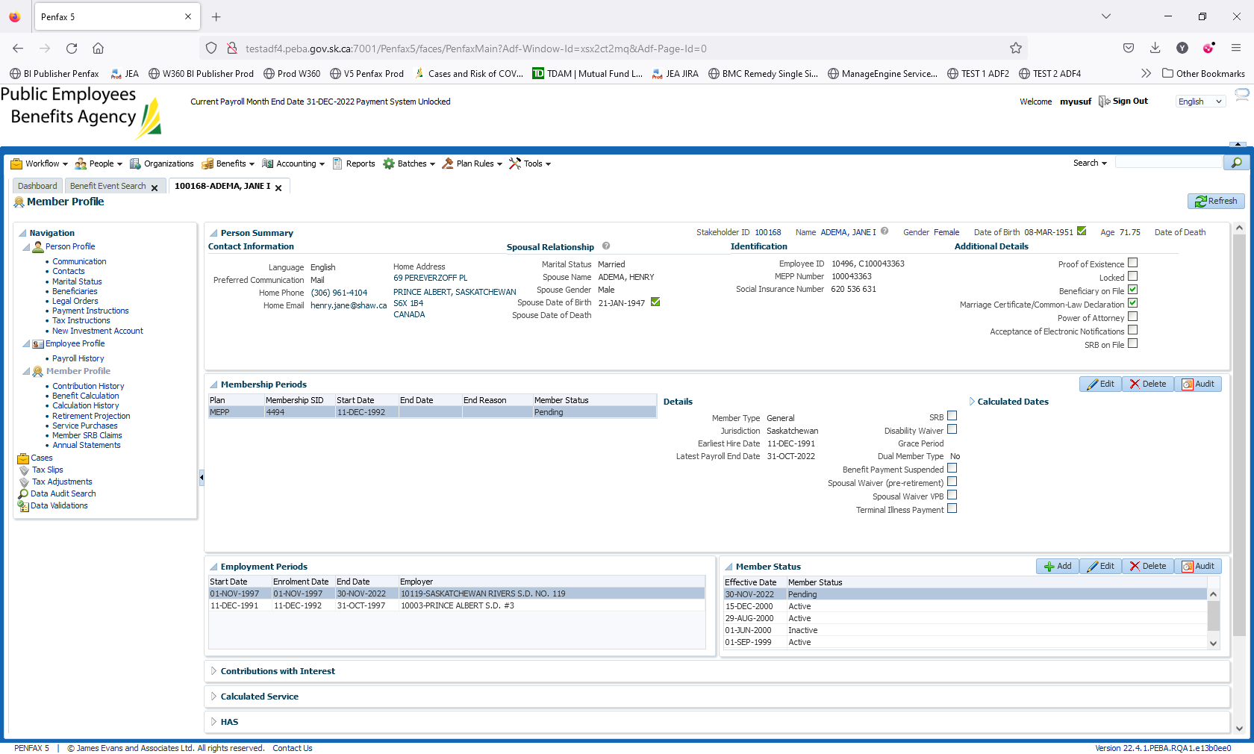

Go to Member profile -> Benefit Calculation

Enter the Termination Date.

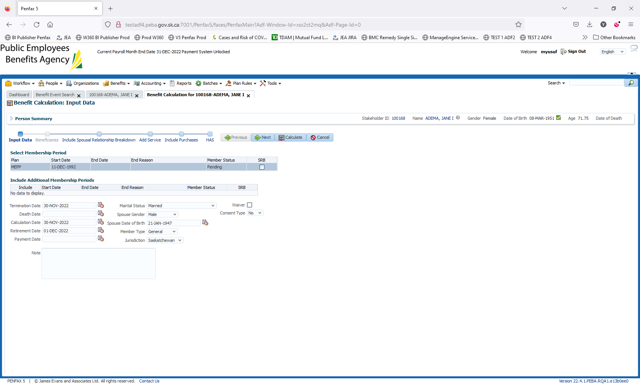

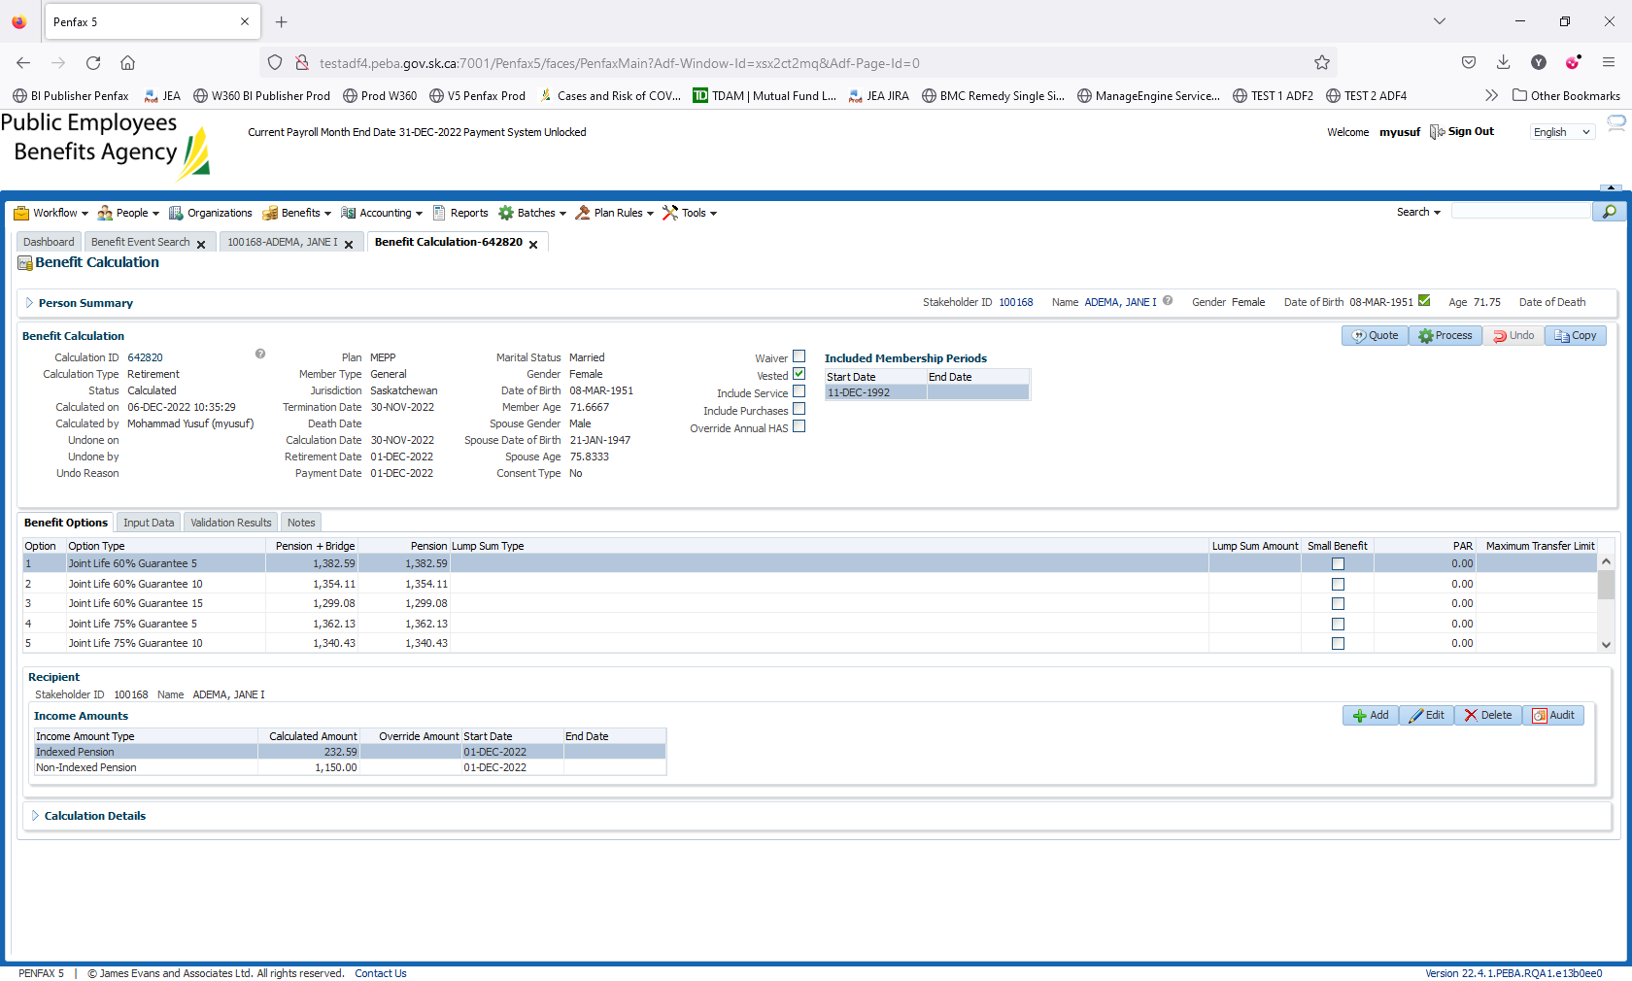

Click on Calculate

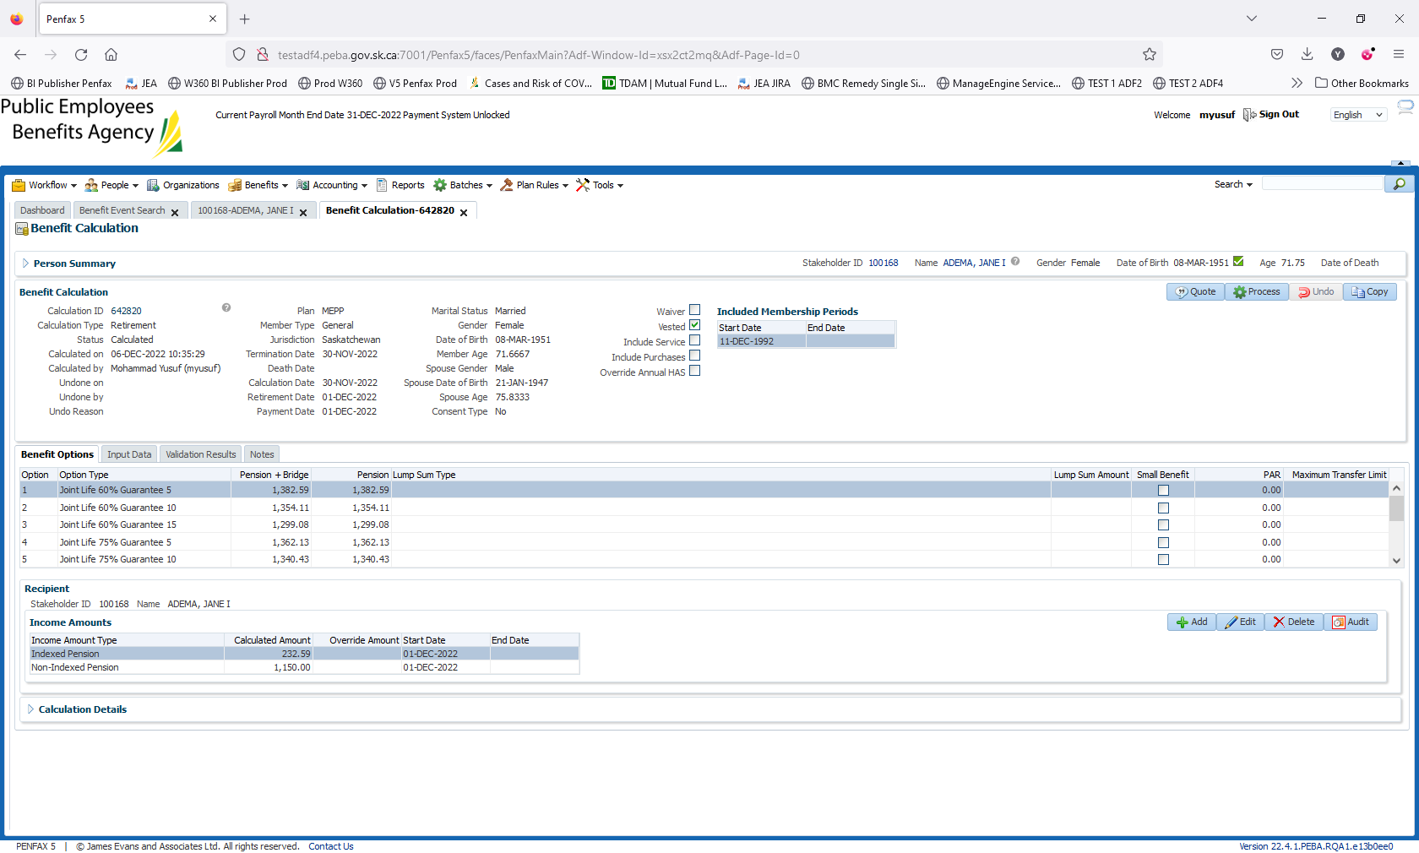

Select the First option 60% with 5 years

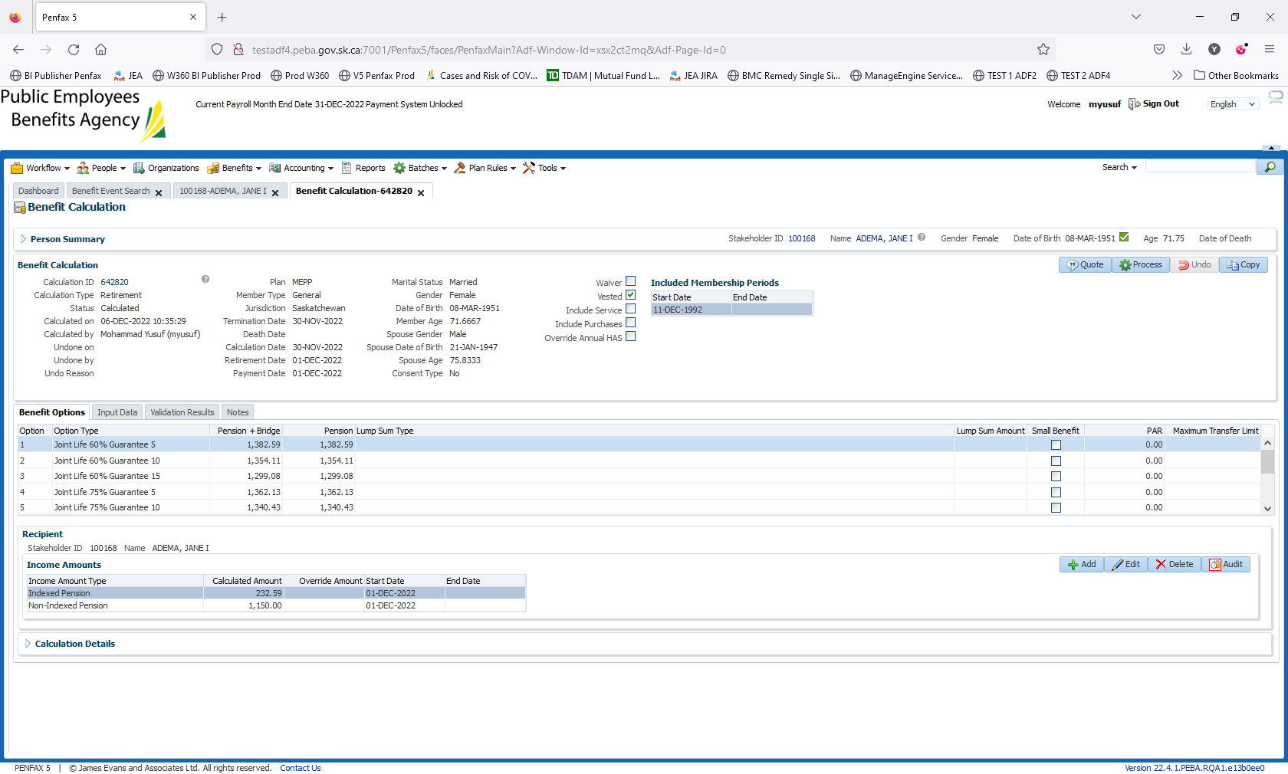

Need to end the employment period first

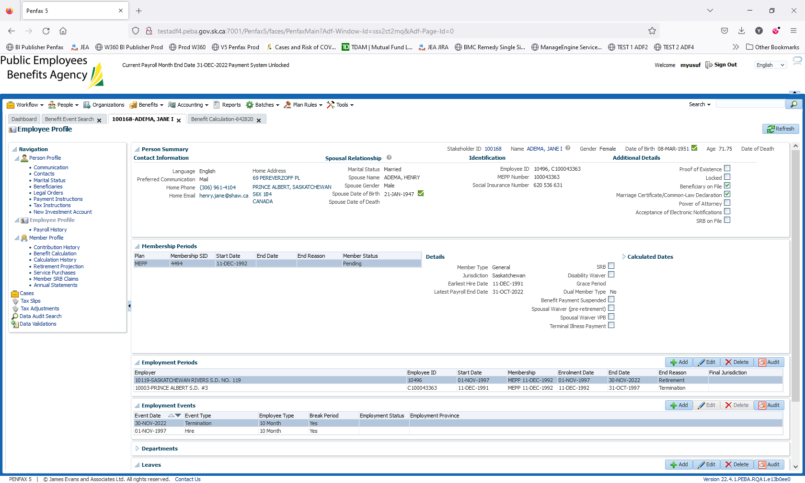

Click on Process

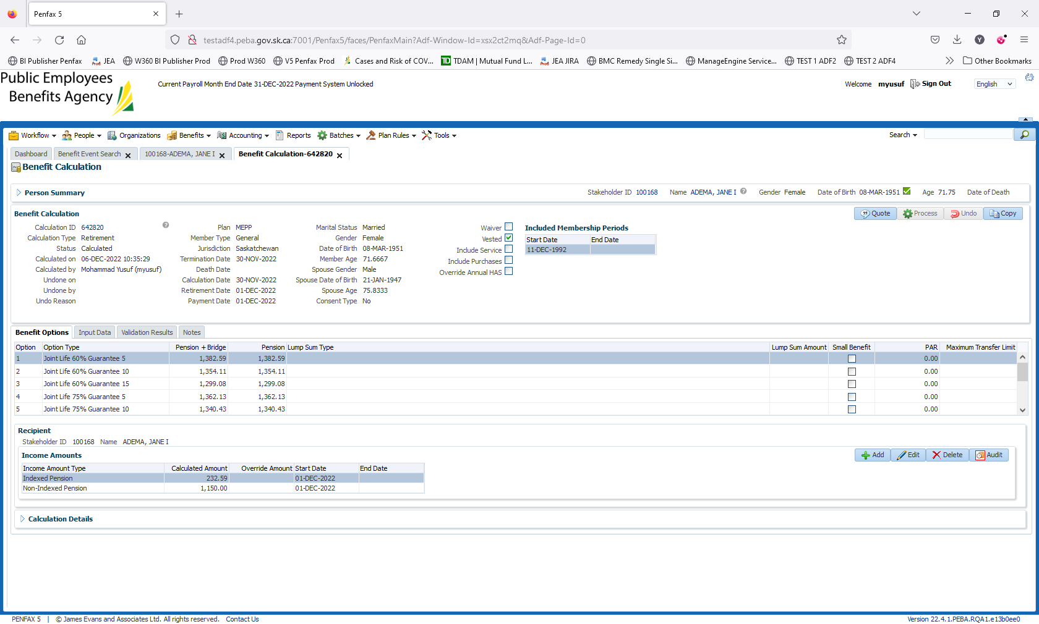

Navigate to Member Profile -> Benefit Selection

Click on Next

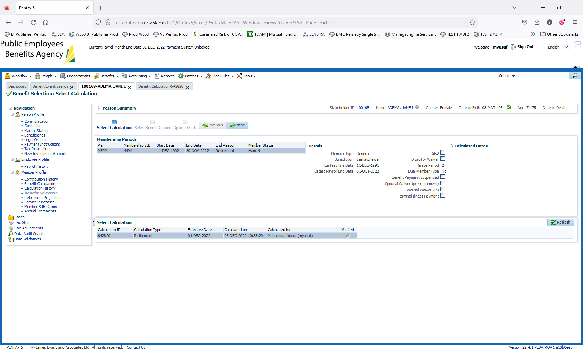

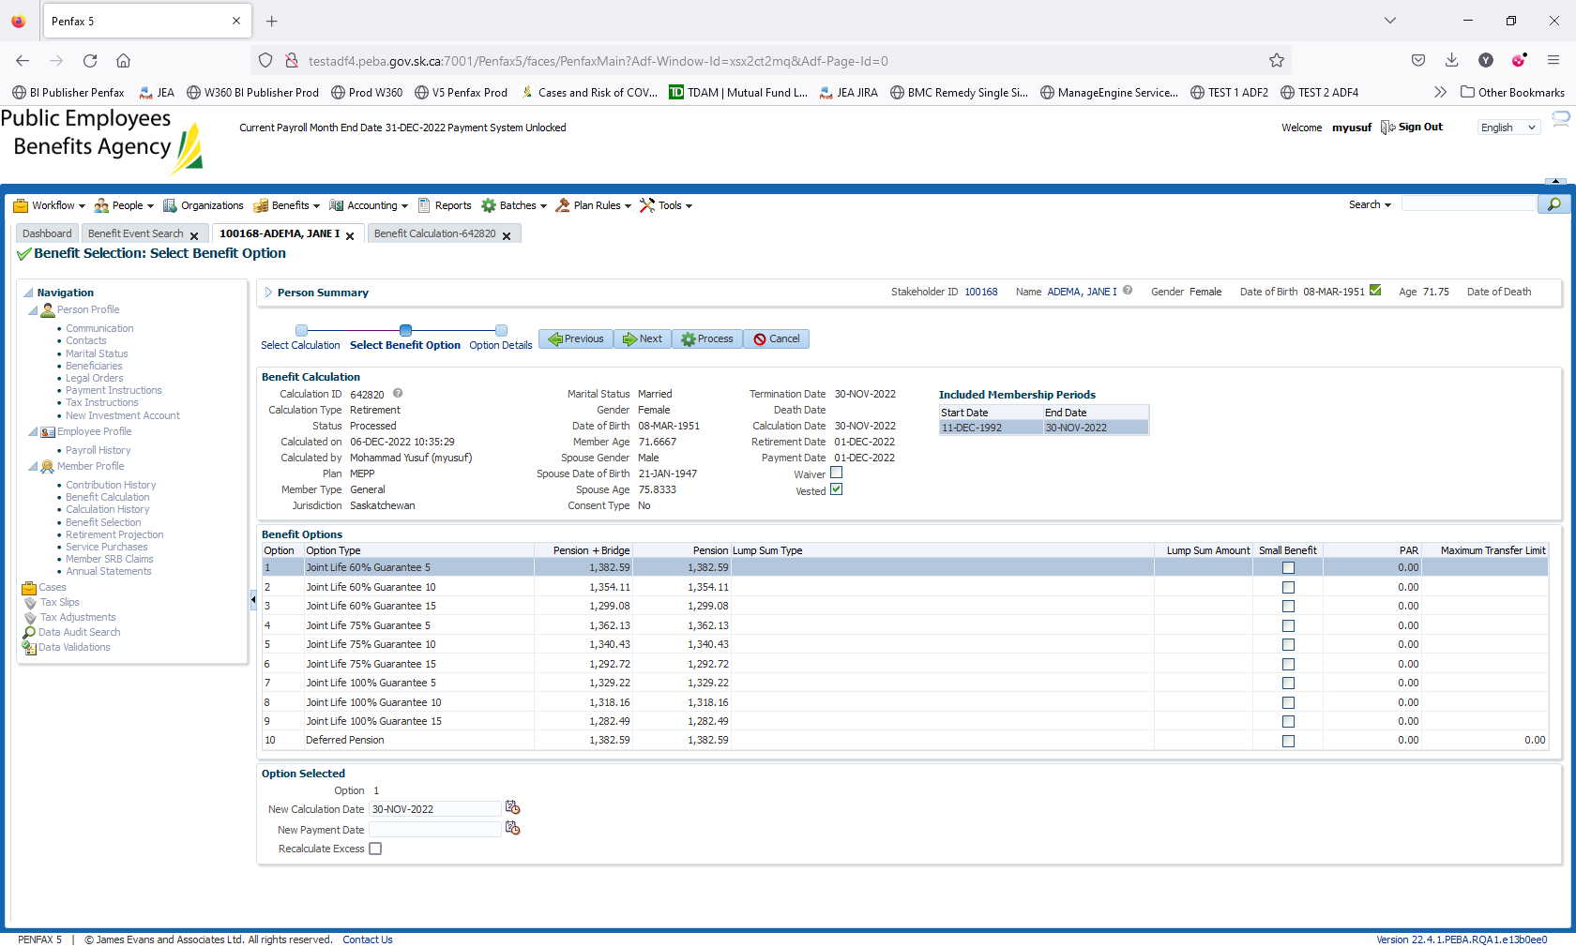

Enter the Payment Date. Click on Process

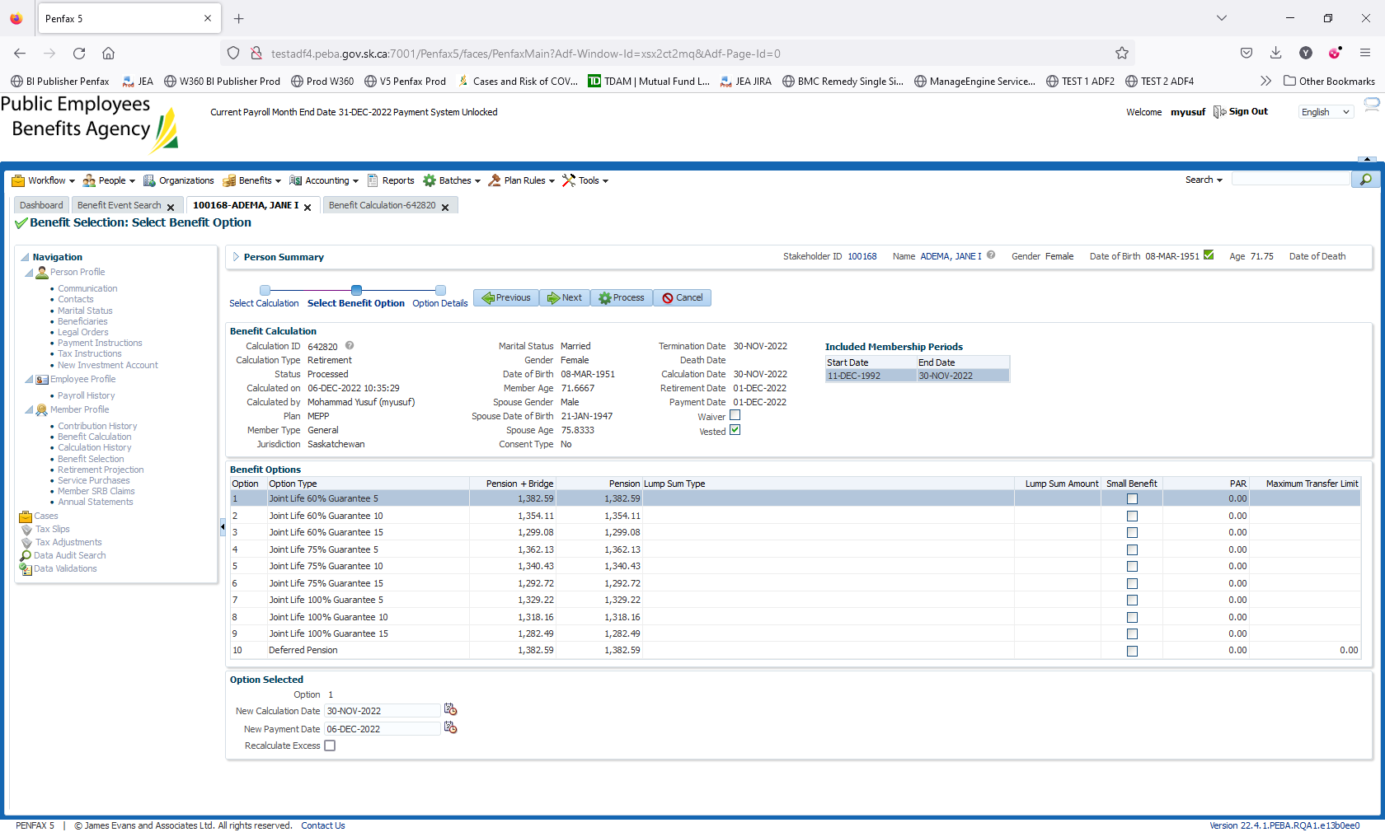

Change the date to Dec 06, 2022

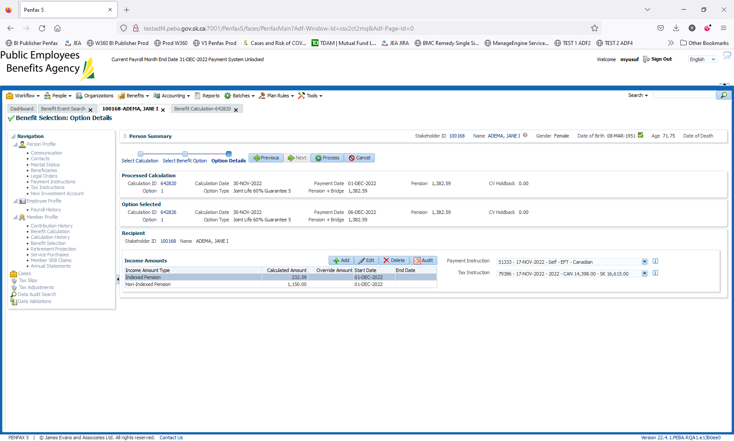

Go to Benefit Recipient -> Select the Benefit Event Id 103279-> Authorize the payment

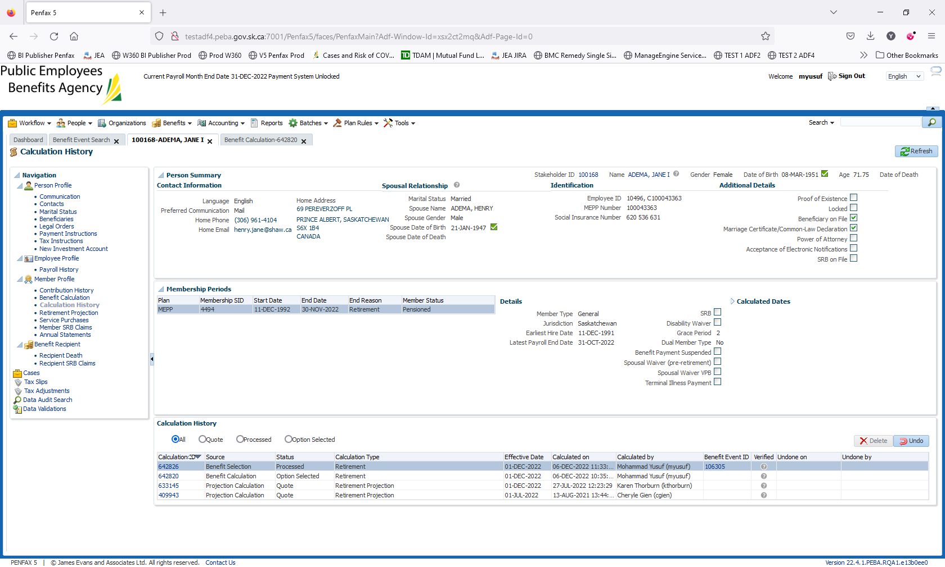

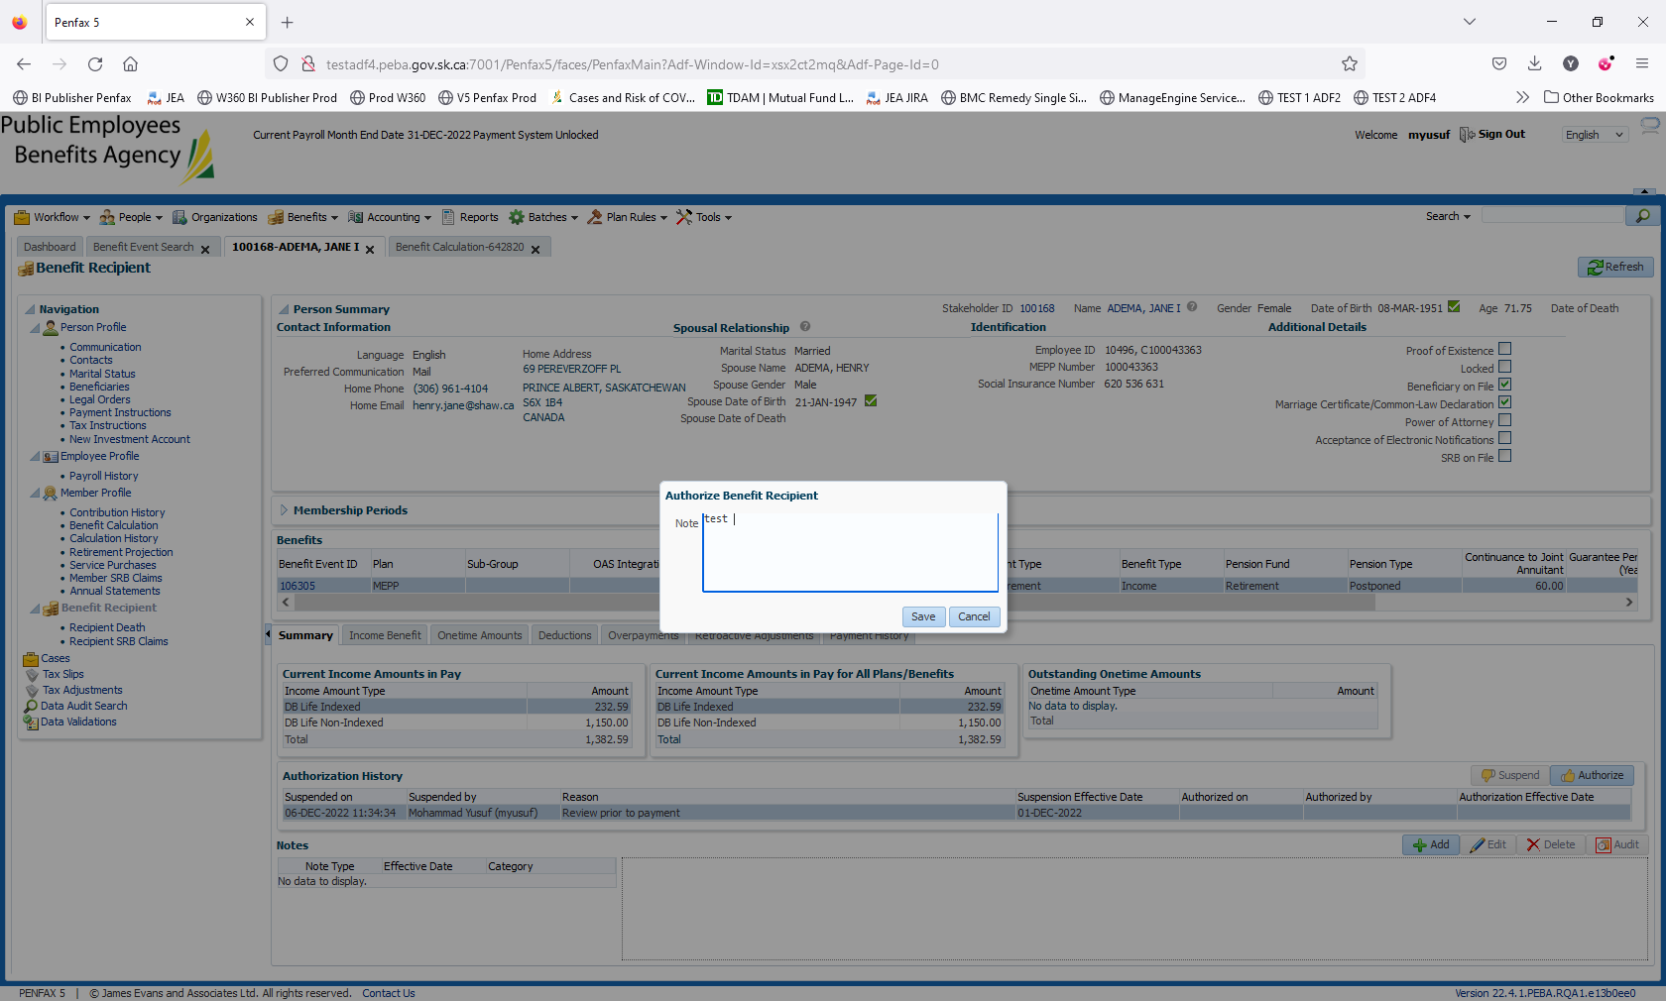

Click on Save

Go to Income Benefit tab and add Payment instructions. Person Profile -> Payment Instructions

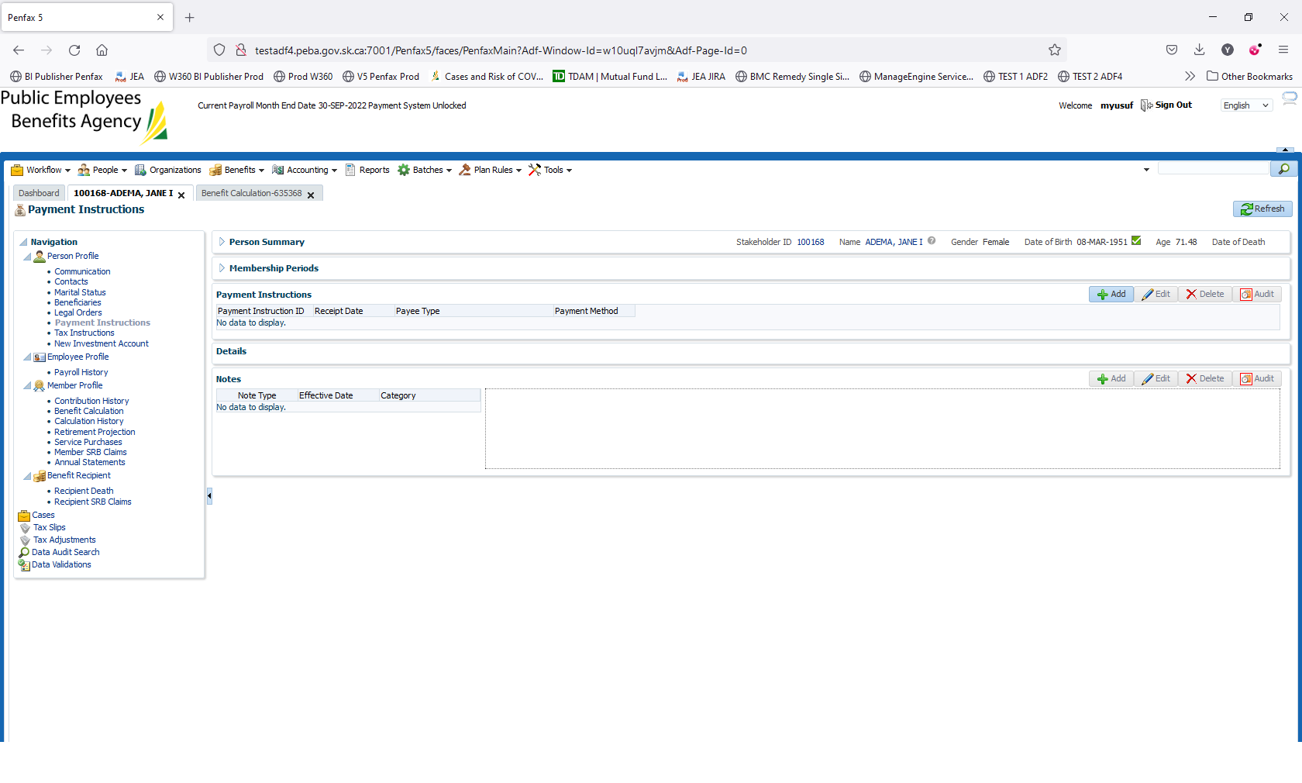

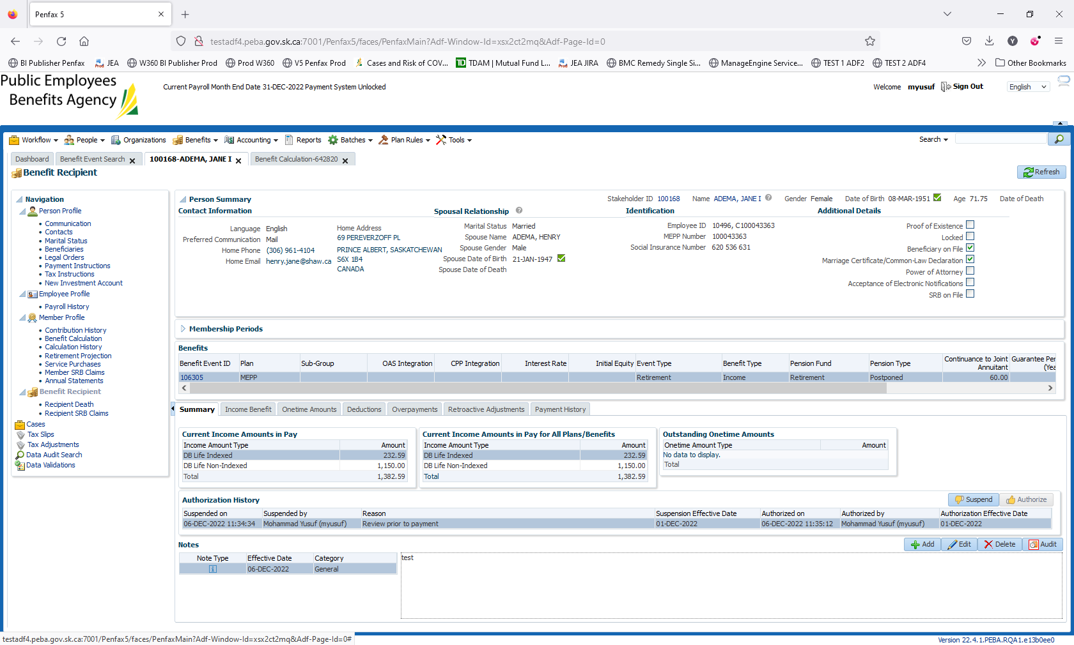

Discuss tomorrow with Cindy to Validate the Process. Member will be Pensioner as of Dec 06, 2022